Q1. WAP to print the following pattern?
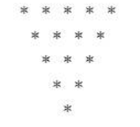
Q2. WAP to print the following pattern?
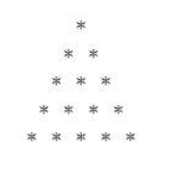
Q3. WAP to print the following pattern?

Q4. WAP to print the following pattern?
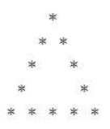

Q5. WAP to print the following pattern?

Q6. WAP to print the following pattern?

Q7. WAP to print the following pattern?


Q8. WAP to print the following pattern?


Q9. WAP to print the following pattern?
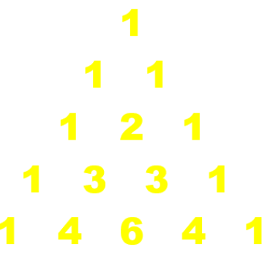
Q10. WAP to print the following pattern?
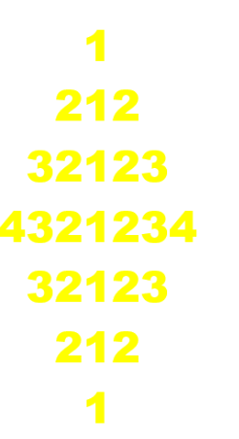

Q11. WAP to print the following pattern?

Q12. WAP to print the following pattern?

Q13. WAP to print the following pattern?


Q14. WAP to print the following pattern?

Q15. WAP to print the following pattern?

Q16. WAP to print the following pattern?


Q17. WAP to print the following pattern?


Q18. WAP to print the following pattern?

Q19. WAP to print the following pattern?
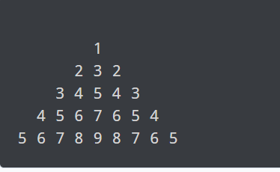
Q20. WAP to print the following pattern?
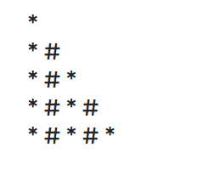

Q21. WAP to print the following pattern?
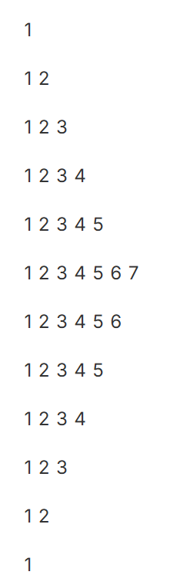

Q22. WAP to print the following pattern?
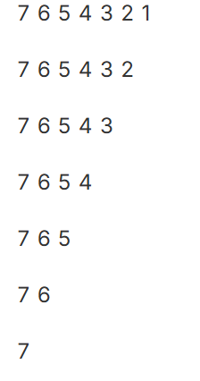
Q23. WAP to print the following pattern?
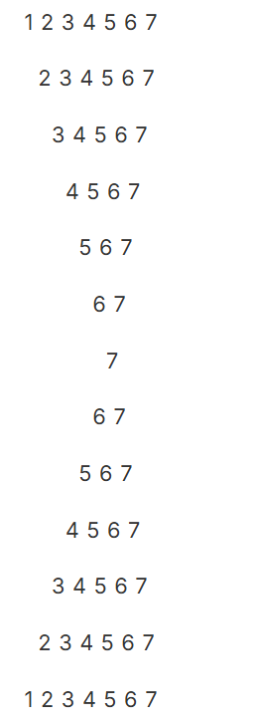

Q24. Write a C program to input binary number from user and find ones complement of binary number using loop. How to find 1s complement of a binary number in C programming. Logic to find ones complement of binary number in C programming.

Q25. Write a C program to input binary number from user and find twos complement of the binary number. How to find 2s complement of a binary number in C. Logic to find twos complement of a binary number in C programming.

Q26. Write a C program to input binary number from user and convert to octal number system. How to convert from binary number system to octal number system in C. Logic to convert binary to octal number system in C programming.

Q27. Write a C program to input binary number from user and convert binary number to decimal number system. How to convert from binary number system to decimal number system in C programming. Logic to convert binary to decimal number system in C programming.

Q28. Write a C program to print Strong numbers between 1 to n. C program to print all strong numbers between a given range. Logic to print strong numbers in a given range in C program.

Q29. Write a program in C to find the sum of the series [ 1-X^2/2!+X^4/4!- .........].
Test Data :
Input the Value of x :2
Input the number of terms : 5
Expected Output :
the sum = -0.415873
Number of terms = 5
value of x = 2.000000

Q29. Write a program in C to display the n terms of a harmonic series and their sum.
1 + 1/2 + 1/3 + 1/4 + 1/5 ... 1/n terms
Test Data :
Input the number of terms : 5
Expected Output :
1/1 + 1/2 + 1/3 + 1/4 + 1/5 +
Sum of Series upto 5 terms : 2.283334
Q30. Write a program in C to find the sum of the series 1 +11 + 111 + 1111 + .. n terms.
Test Data :
Input the number of terms : 5
Expected Output :
1 + 11 + 111 + 1111 + 11111
The Sum is : 12345

Q30. Write a program in C to find the prime numbers within a range of numbers.
Test Data :
Input starting number of range: 1
Input ending number of range : 50
Expected Output :
The prime number between 1 and 50 are :
2 3 5 7 11 13 17 19 23 29 31 37 41 43 47

Q31. Write a C program to find Strong Numbers within a range of numbers.
Test Data :
Input starting range of number : 1
Input ending range of number: 200
Expected Output :
The Strong numbers are :
1 2 145

Q32. Write a program in C to check whether a number can be expressed as the sum of two prime.
Test Data :
Input a positive integer: 16
Expected Output :
16 = 3 + 13
16 = 5 + 11

Q33. WAP to find the Pair cube count ?
Given N, count all ‘a’(>=1) and ‘b’(>=0) that satisfy the condition a³ + b³ = N.
Input:
N = 9
Output:
2
Explanation:
There are two solutions: (a=1, b=2)
and (a=2, b=1).

Q34. Find all pairs (sets) of prime numbers (p,q) such that p*q <= n, where n is given number.
Example 1:
Input: n = 4
Output: 2 2
Explanation: Pair (2, 2) which has both prime
numbers as well as satisfying the condition
2*2 <= 4.
Example 2:
Input: n = 8
Output: 2 2 2 3 3 2
Explanation: Pairs(2, 2), (2, 3) and (3, 2)
which has both prime numbers and satisfying
the given condition.

Q35. Given two integer values n and r, the task is to find the value of Binomial Coefficient ^{n}C_{r}
- A binomial coefficient ^{n}C_{r} can be defined as the coefficient of x^r in the expansion of (1 + x)^n.
- A binomial coefficient ^{n}C_{r} also gives the number of ways, disregarding order, that r objects can be chosen from among n objects more formally, the number of r-element subsets (or r-combinations) of a n-element set.
Note: If r is greater than n, return 0.
Examples:
Input: n = 3, r = 2
Output: 3
Explaination: ³C₂ = 3.
Input: n = 2, r = 4
Output: 0
Explaination: r is greater than n.

Q36. Given a number N. Find the last two digits of the Nth fibonacci number.
Note: If the last two digits are 02, return 2.
Example 1:
Input:
N = 13
Output:
33
Explanation:
The 13th Fibonacci number is 233.
So last two digits are 3 and 3.

Q37. Write a Program to print Factors of a Negative Integer

Q38.

